Labelling using Anaconda and Label Studio
Download and install Anaconda if you haven’t already: https://www.anaconda.com/download
Open Anaconda Navigator and (install if necessary) launch anaconda_prompt OR search for anaconda prompt on your device and launch it.
A terminal should open. Next write/copy the text in bold italics:
conda create --name ExampleName python=3.12 -y
conda activate ExampleName
pip install label-studio
label-studio start
You should see the Label Studio open in a browser. Click “Sign Up”. Since this version of Label Studio is running locally, you can enter any Email Address and Password be it fake or real.
LABEL STUDIO
Create project > labeling setup > select “Object Detection with Bounding Boxes”> delete existing labels > add new one > press enter > repeat until all your desired classes are in the list. Example:
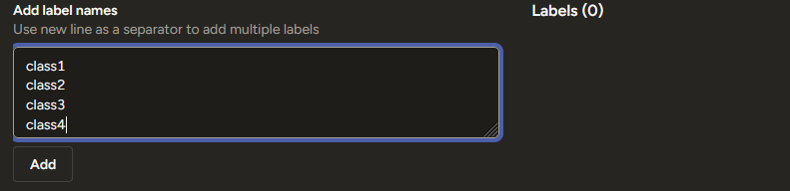
Click “Add”.
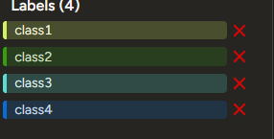
Data Import > Upload files > Do NOT import more than 100 at a time (Label Studio can’t handle it) > upload more files if needed, for example: upload 100 images, upload another 100 images, upload 43 images.
Project name > anything you want > Press “SAVE”
You’re all setup! Now just select an image and start labelling.
ALWAYS REMEBER TO SUBMIT AFTER YOU’RE DONE WITH THE LABELS FOR AN IMAGE.
After you’re done with labelling all your images click “Export” and select “YOLO with Images”. After a while, it should download a Zip-file containing all of the images, labels and classes. notes.json can be deleted.
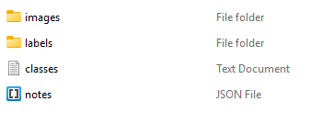
Unzip the file and move the folder to a desired location. Remember to check that after opening the unzipped folder, it opens straight to a view like in the image above (meaning that it does not have any extra folders you need to click to reach this point).

TRAINING YOLO MODELS LOCALLY
Prerequisites (currently only tested on NVIDIA GPUs):
Install anaconda if you haven’t already. Create/open an environment eg.:
conda create --name ExampleName python=3.12 -y
conda activate ExampleName
install ultralytics if it is not installed
pip install ultralytics
To run training on the GPU, we need to use the GPU-enabled version of PyTorch. Run the following command to install the GPU version of PyTorch:
pip install --upgrade torch torchvision torchaudio --index-url https://download.pytorch.org/whl/cu124 (<- this url is part of the command)
You can confirm PyTorch-GPU is correctly installed by issuing the following command in the Anaconda Prompt terminal:
python -c "import torch; print(torch.cuda.get_device_name(0))”
If CUDA was installed correctly, this command will return the name of the GPU installed in your system. For example:

IF YOU RUN INTO PROBLEMS (in your environment) uninstall pytorch:
pip uninstall -y torch torchvision torchaudio
or (depending on if you used conda and not pip to install it)
conda uninstall -y pytorch torchvision torchaudio
Purge Conda's cache to force fresh fetches:
conda clean --all --yes
(Re)install pytorch (with the environment active):
conda install -y pytorch torchvision torchaudio pytorch-cuda=11.8 -c pytorch -c nvidia

To Train:
For the model to be able to train, you need to create a data structure like in the image below:
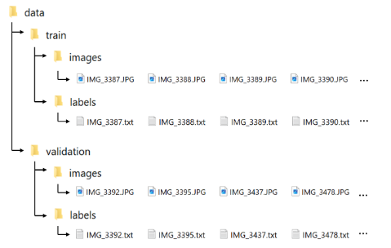
Download automatic splitter script using command:
curl --output train_val_split.py https://raw.githubusercontent.com/EdjeElectronics/Train-and-Deploy-YOLO-Models/refs/heads/main/utils/train_val_split.py (<- url is part of the command)
If you used the command without having used “cd”, the file is most likely found in the folder C:\Users\username\. Remember that “username” part of the command(s) are just an example, your pc most likely has your own username instead. Put the script into the folder you wish to create the data folder into. Then in Anaconda prompt move to that folder using “cd path\to\data”. An example could be something along the lines:
cd C:\Users\username\Documents\YOLOs
Quick way to find out your path is to open the folder in the File Explorer and click the path in the top and copying it.
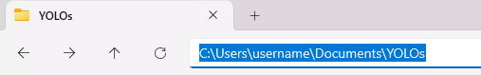
In the train_ val_split.py file, you can change the --train_pct parameter at the end. It determines the portion of images that are used for training, and the rest is for validation (values are between 0 and 1, 0 = 0% and 1 = 100%). Change the datapath to match the path to your dataset folder. (It is the folder that contains the "images" and "labels" folders). For example, if your images and labels are in a folder named “LabelledImages” and you are in the same folder that it is located, your datapath should be:
LabelledImages
OR (whichever you prefer)
C:\Users\username\Documents\YOLOs\LabelledImages

Now, Run the script.
python train_val_split.py --datapath=path\to\data --train_pct=.8
After running the script, ensure your data structure matches the image. The folder HAS TO BE NAMED “data”.


Create a training configuration file: (data.yaml)
open text editor and make a file similar to the one below:
path: C:\Users\username\YOLOs\data
train: train/images
val: validation/images
nc: 8
names: ["className1", "className2", "className3", "className4", "className5", "className6", "className7", "className8"]

Where:
path = path to your data folder
nc: [number of classes]
names: list all classes as above MAKE SURE THE CLASSES ARE IN ALPHABETICAL ORDER (copy from classes.txt in the original dataset folder).
Save it as “data.yaml” and put it in the same folder as the data folder (not inside, but on the same level).
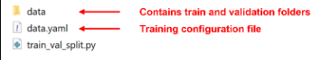

TRAIN MODEL:
You should have the model downloaded and located in the same root folder as data and data.yaml.
Download link: https://docs.ultralytics.com/models/yolo11/#performance-metrics
You can also use a previously trained model to fine tune it or alternatively, if you just type the name of one of the officials, like yolo11s.pt here, it will automatically download it from GitHub. The model (yolo11s most likely) will be downloaded if you don’t have one installed in the correct folder or if the name is wrong. We'll use YOLO11s here:
yolo detect train data=data.yaml model=yolo11s.pt epochs=60 imgsz=640
Remember to still be in the environment and the correct folder. The folder should have data, data.yaml, (model if downloaded). This would train on yolo11s model for 60 epochs at 640x640 resolution with no additional parameters.
Additional parameters can include augmentations. You can add these into the command in any order:
hsv_h=0.3
hsv_s=0.6
hsv_v=0.5
(these are hue, saturation and brightness, with example values (h=0.3 is quite aggressive)) scale=0.3 (randomizes scale between 70% and 130%) perspective=0.001 degrees=180 so an example command would be:
yolo detect train data=data.yaml model=yolo11s.pt epochs=200 imgsz=640 hsv_h=0.3 hsv_s=0.6 hsv_v=0.5 scale=0.3 perspective=0.001 degrees=180
for a full list of all available augmentations see: https://docs.ultralytics.com/guides/yolo-data-augmentation/

